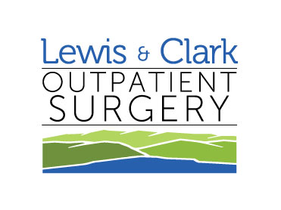
Low Fat Diet

DR. DETTWILER

Approximate Approximate
Protein 80 grams Carbohydrates 300 grams
Fat 50 grams Calories 2000 grams

This diet is low in fat but calories are made up by increasing carbohydrates. Generous servings of green and yellow vegetables should be eaten daily to provide adequate Vitamin A.

This diet is used for patients with gall bladder and liver dysfunction, delayed stomach emptying, malabsorption, and diarrhea.

The principles of this diet are to provide adequate nutrition while reducing the amount of fat (1/2 -1/3 lower than the regular diet) so as not to stimulate the flow of bile.

Food Allowed Food to Avoid
Soups: Skimmed meat or chicken Creamed soups made with whole milk.
broth with no visible fat.
Broth or skimmed milk soups.

Meat: Tender lean beef, pork, veal, Fatty meals including bacon, sausages,
lamb, chicken, turkey, or fish. frankfurters, or luncheon meats, Fish
Trim all visible fat, do not fry canned in oil. Peanut butter.

Eggs: One egg daily prepared any
way except fried. Egg whites
as desired.

Cheese: Dry cottage cheese or low fat All others.
cheese.

Vegetables: All kinds as tolerated without
fat.

Fruits: All fruits as tolerated except Avocadoes
avocadoes.

Breads/ Any enriched or whole grain Quick breads, sweet rolls, donuts,
Cereals: bread, saltines, graham pancakes, waffles, variety crackers,
Crackers, macaroni, spaghetti corn chips, potato chips, granola.

Desserts: Fruit, fruit gelatin, fruit pies, Pies, cakes, ice cream. Anything with
Plain angel food cake, frozen nuts, chocolate, cream, whole eggs,
yogurt, ice milk, or sherbet, whole milk, or coconut.
hard candies, gumdrops,
marshmallows.

